Which regions do you require certification for?
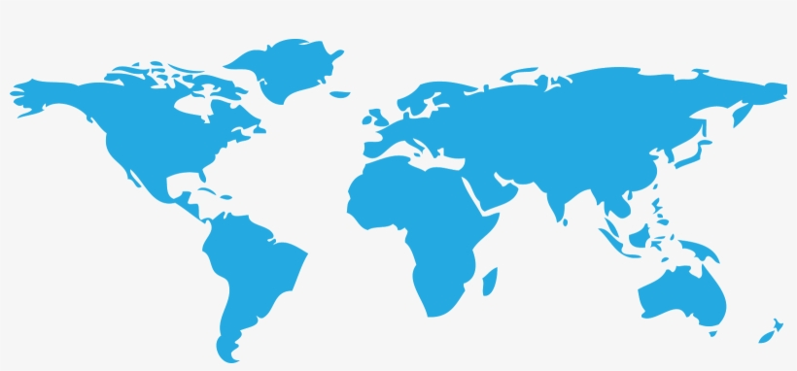 |  |  |  |  |  | ☐ International
 |  |  |  | UK | ☐
USA and Canada |  | ☐ |  |  | ☐ | Europe |  |  | ☐ South Korea
 |  |  |  |  |  |  | China ☐ |  | ☐ Japan
 |  |  | ☐ | Brazil
 |  |  |  |  |  |  | Australia |  | ☐
 |  |  |  | South Africa |  | ☐
Any other regions

Project scope
Prime Certification of a new product: |  | ☐ |  | Variation to an existing Eurofins CML certified product: |  |  | ☐
Trade Agent - A copy of a certificate in the name of another manufacturer: |  | ☐ |  | Recertification of a product previously certified by another Body: |  |  | ☐
Certification service
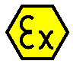 | ATEX Certification |  | ☐ |  |  | Japanese Approval |  | ☐
 | IECEx Certification |  | ☐ |  |  | Mining Approval Services (MA China, MSHA US) |  | ☐
 | UKEX (UKCA) Certification |  | ☐ |  | 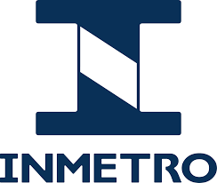 | INMETRO (Brazil) Service |  | ☐
 | North American approval (Eurofins MET) |  | ☐ |  |  | KCs Ex Certification (Korea) Service |  | ☐

Where would you like the quotation and invoices for services to be sent?
 | Quote to: | Invoice to: (if different) | Manufacturer (if different)
Name of Contact Person
Position
Contact Number
Email address
Company Name
Company Address
For certification purposes, the “manufacturer” of a product is the person who assembles, packs, processes, or labels ready-made products with a view to placing it on the market under their own name. The responsibility for product compliance is born by the Company appearing on the product label or if more than one name appears is marked as the manufacturer. This is irrespective of the owner of relevant intellectual property or the physical place of manufacture or assembly. The manufacturer location(s) are subject to surveillance of manufacture dependent on the certification scheme requirements. For example, Quality Assurance Notification for ATEX or UKEX and Quality Assessment report for IECEx.

Product(s)
Name of product (This will appear on the certificate)
Description of products or range, state number of model variations and applicable build options and function.
List Methods of Protection Concept, Zone and if the product is for Gas/Dust/Both.
If applicable ATEX Directive / UK Directive marking required
e.g. II 2 G
Ambient temperature range
(Assumed to be -20°C to +40°C) if left blank
Ambient pressure |  |  | Contact us if your product is used outside the ambient pressure range 0.8 bar to 1.1 bar
List any existing certificates that cover part or all of the products to be certified
Any additional information
Do you have a Quality system approval in place? I.e., ATEX QAN, IECEX QAR etc?  If yes, please provide details. | Yes | No | Do you require Quality System Approval?  If this approval is required, we will send a separate application form to gather the information to provide a quote. | Yes | No
 | ☐ | ☐ |  | ☐ | ☐

Documentation Required for Preparing a Quotation
Before the project can be completed, please send copies of the following documents, if applicable:
- Complete set of certification drawings, in pdf format, including marking details.
- General arrangement drawing including where applicable range specification and options designation.
- Copy of relevant product test reports and other certification body certificates plus variations to those certificates. Include documentation for the whole product and for any incorporated certified products.
- Copy of Quality Management system approvals e.g. QAN, UK QAN, QAR, ISO9001 certificates etc
- Product operating manual and maintenance instructions or extract thereof demonstrating compliance with EHSR 1.0.6
- Declaration of Conformity with other relevant directives

Declaration
In submitting this quote request to Eurofins E&E CML Limited. The applicant attests that:
- The rights to any certificate issued shall rest with the manufacturer(s) stated.
- New products(s) have not been certified by or submitted to another certification body.
- They have the authority to represent, submit the request, agree terms on behalf of the manufacturer.
- The manufacturer is aware of and is able to make a declaration to comply with the rules and regulations of the applicable Eurofins E&E CML Limited certification scheme.
- Unless otherwise stated in this quote request that no consultancy service has been used in the product design or management system applicable to this product.
Signature | The manufacturer and/or applicant possesses the necessary rights to the product and its design.
 | The product and associated documentation, drawings and data submitted to Eurofins E&E CML Limited are not regulated by local or international export or transfer regulations.
Date | To provide a purchase order number and sign the quotation acceptance when ready to proceed with the service.

Why Choose Eurofins E&E CML for your certification and testing?

Eurofins E&E CML are an industry leading Certification Body, specialising in testing and certification of Hazardous Area equipment. We focus on being responsive, competent, credible, and innovative in our approach. Our experienced team will be pleased to assist you with:

- ATEX and IECEx certification
- Japanese approval
- North American approval
- UKCA marking
- Global marks (such as INMETRO & KCs)
- MSHA testing and approval service
- Laboratory testing
- IP testing
- Technical support

Did you know that Eurofins E&E CML are a part of the Eurofins Group?
Eurofins E&E UK are a provider of world-class testing, inspection, approval and certification services for manufacturers, product designers, importers, and retailers of electrical and electronic products.
Eurofins can help with:

- Electromagnetic Compatibility - EMC
- Radio/Wireless Testing
- IECEE CB Scheme
- Global Product Certification Marks
- Product Safety for Electrical Equipment
- Scheduled & bespoke Product Compliance training
- Test equipment calibration

